**Page 1.0 (Landing Page)**

**page 1.0(登陆页面)**

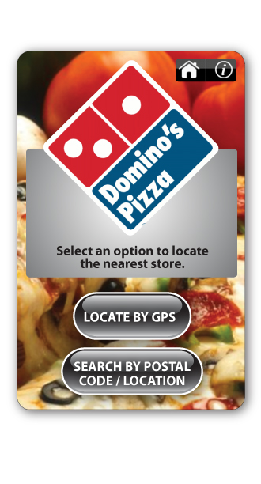

|  |
| --- |
| donmino’s pizza (选择定位最近的商店) |
| 用GPS定位 |
| 通过邮编/地址搜索 |

**Interactive Elements 交互组件**

* Global persistent menu D:\Project Docs\FromOthers\Domino\home-info.pngat top to allow the user to easily navigate between sections. Version 1.0 of our app will only have 2 buttons, a home button and an info button. The menu will be expanded in future versions to accommodate other buttons such as: “Product Search”, “Coupons”, “Menus”, “Settings" etc...
* 在上端的全球持续菜单D:\Project Docs\FromOthers\Domino\home-info.png，便于用户在选项间导航。1.0版本应用程序只有2个home按钮和一个info（信息）按钮。将来版本将扩充菜单，提供其他按钮，像“产品搜索（Product Search）”，“优惠劵（Coupons）”，“菜单（Menus）”，“设置（Settings）”等…
  + **Home button** – Allows the user quick access to the landing page.
  + Home按钮——允许用户快速访问登陆页面。
  + **Info button** – Clicking on this button will bring the user to a page which shows general information about the company**(9.1)** – ie. Company Name, website address, corporate phone number, app version number.
  + 信息（info）按钮——点击此按钮，用户将进入页面，显示有关公司（9.1）的大概信息——如。公司名称，网址，公司电话号码，应用程序版本号。
* Find store buttons
* 查找商店按钮

Figure 1 Work flow for "Find a store"

图1 “查找商店”工作流（缺图，回头整）

1. **Locate by GPS** – Clicking on this button will locate all stores closest to your current location, as determined by the GPS （GPS定位——点此按钮将定位距离你当前位置最近的所有商店，这由GPS决定）
   1. If app cannot get the GPS location at that time, in the same page message (**Message101**) "**We are sorry, but your location could not obtained at this time. Please try searching by postal code/location** " will displayed. （如果应用程序不能获取GPS定位，同一页面显示<消息101>“非常抱歉，但不能得到您的位置。请用邮编/位置尝试搜索”。
   2. If current GPS location available, call webservice and get all stores around and display page 2.1. 如果当前GPS定位可用，调webservice，获取周围所有商店并显示页面。
2. **Locate by Postal Code/Location** – Clicking on this button to a page where you can manually enter a postal code, address or city (Page 2**) 通过邮编/位置定位——点击此按钮，到达手动输入邮编、地址或城市的页面（第二页）。**

**Page 1.1 (Find a store)**

**1.1页面（查找商店）**

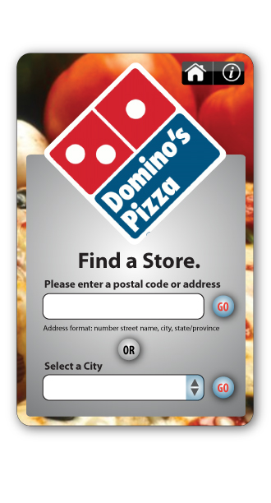

**Interactive Elements 互动组件**

**Postal code/address search field** – Users can search a store by postal code, or by address. Address is inputted in the following format: *number street name, city, province*. Search results work much the same as locating by GPS. Hitting the Go button will bring the user back to Page**1.2**.

邮编/地址搜索区域——用户能通过邮编或地址搜索商店。地址输入格式如下：号码 街道名称，城市，省份。和GPS定位一样搜索结果。点击Go按钮，用户将回到1.2页面。

**Select a City dropdown menu** – Users can also search by city. The city list is pre-populated from a list which the vendor gives us. When the user hits the Go button, the results for all stores for a given city will be displayed (Page 1.2)

选择城市下拉式菜单——用户也能根据城市查询。城市菜单从供应商预先列的单子来。当用户点Go按钮，显示给定城市的所有商店的结果（1.2页面）。

When searching by city, and navigating down to the store’s information , we will not have an initial point to determine directions to the store. In this scenario, when the user clicks on “Directions”, a popup window should appear, prompting the user to input a postal code or an address. Once a postal code or address is entered, the user will be brought back to the turn by turn directions page (Page 6.1)

当根据城市搜索，导航商店信息，我们没有初始点决定商店的方向。在这儿，当用户点击“定向（Directions）”,出现弹出窗口，用户输入邮编或地址。一旦输入邮编或地址，用户将回到turn by turn direction页面(6.1页面)

*Note : The city list come from all server, it is pre-load when the app start up. Only cities in which the Branded company has physical locations will be returned.

If the user input postal/address, the app first call a service (now suggest Google) to convert the address/postal to latitude, longitude and then call webservice to get the store list.

if get no results from server, message (**Message102**)"Sorry, there are no locations close to the postal code/address that you entered." will be displayed.

注意：城市列表来源于所有服务器，在应用程序启动时是预先加载的。仅返回拥有物理地址的品牌公司的城市。

如果用户输入邮编/地址，应用程序首先调用服务（现在建议Google）转换地址/邮编为纬度，经度，然后调用webservice获取商店列表。

如果从服务器无法获取结果，显示消息<消息102>”对不起，您输入的邮编/地址附近没有定位”。

After call webservice, if no stores found, show message (**Message103**) " No locations found for the postal code/address that you entered. "

调用webservice后，如果查寻不到商店，显示消息<消息103>“您输入的邮编/地址没有发现定位。”

**Page 1.2 Store List**

**1.2页面 商店列表**

**(need design) （需要设计）**

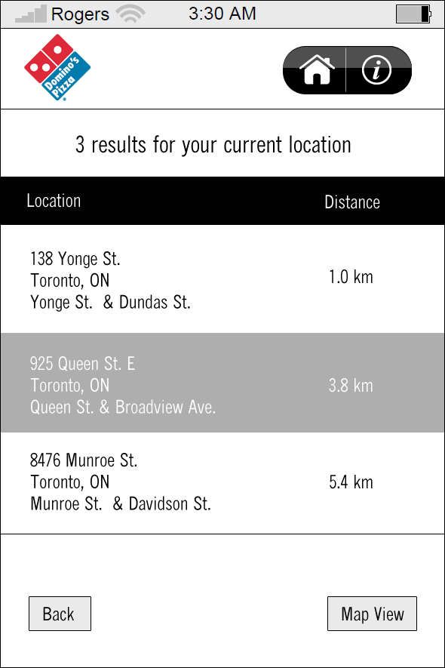

All the stores in the list sorted by distance based on the current location, if searched by city, use the sort from server (all will be sorted by some rule).

列表中所有商店基于当前位置，依距离分类，如果根据城市搜索，用服务（器）的分类（功能）,全部根据一些规则分类。

All the results will be displayed on one page(*), and use scroll key down/up view.

所有结果将在同一页面显示（*），用滚动键上下浏览。

**Interactive Elements 互动组件**

**Back Button** – Back button will allow the user to go back to the previous page.

**返回按钮**——返回按钮允许用户返回先前页面。

**Individual Store Listing** – Selecting this will bring you to a page with the store listing’s information, such as address, phone number etc... (2**.2**).

**单个商店展示**——选这个，将到商店显示信息的页面，例如地址，电话号码等…（2.2）的页面。

**Map View** – Clicking this will bring the user to a map which shows all results in a map (**3.1**)

**地图浏览**——点这个，将到显示结果的地图的页面。

**Page 2.2 Store Detail**

**2.2商店详情**

**(need redesign the buttons)**

**(需要重新设计此按钮)**

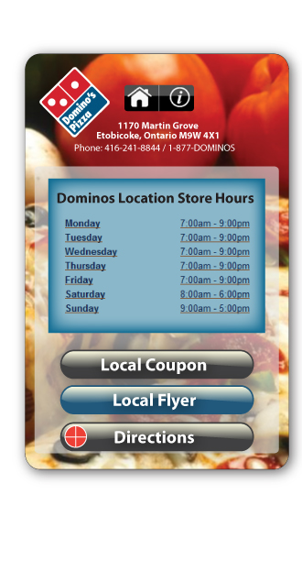

**Interactive Elements 互动组件**

**Local Coupon** – Get the coupons from webservice, if no coupon assigned to this store, show message (**Message104**) "There are currently no coupons available.", if has coupon, enter the coupon page to show a list of coupons of this store(**page 4.1**)

当地优惠劵——从webservice获取优惠劵，如何指定商店没有优惠劵，显示消息<消息104>“当前不存在可用优惠劵”，如果有优惠券，进入优惠券页面，显示这个商店的优惠劵列表。

**Local Flyer** – Get the flyer list from webservice, if no flyers assigned to this store, show message (**Message105**) "There are currently no flyers available", if has flyers, enter the flyer page to show a list of flyers of this store(**page 5.1**)

**当地传单**——从webservice获取传单列表，如何指定商店没有传单，显示消息<消息105>“当前不存在可用传单”，如果有传单，进入传单页面，显示这个商店的传单列表。

**Directions** – Pressing this button will popup a window (page 2.3) to ask user the start point.

if select to use current location, then try to get current GPS location, Pressing this will bring the user to a page with turn by turn directions. The directions will be from the nearest location that was determined by the GPS to the chosen location of the store (**page 6.1**).

定向——按此按钮，弹出窗口（2.3页面），需要用户的起始点。如果选择使用当前位置，则获取当前GPS位置，按此键，到turn by turn定向界面。该定向将从GPS 决定的最近位置到选定的商店位置（6.1页面）。

Back Button – Back button will allow the user to go back to the previous page.

Call – Clicking on this button will start the device’s phone application, and automatically call the store’s number (if the number specified).

返回按钮——用户返回到前一页面。

电话——点此键，启动设备的电话程序，自动拨打商店号码（如果指定了号码）。

**Page 3.1 (Store Listings in Map View)**

３.1页面（地图视图里的商店列表）

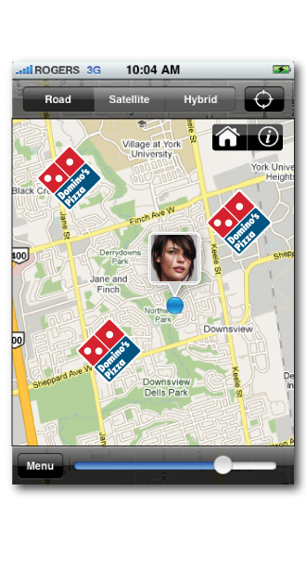

When Map View is selected from the results, the application will display all results on a map as pins, and use the logo as the pin

从结果里选择了地图视图，程序在地图上像大头针显示所有结果，像大头针一样使用logo

**Interactive Elements 互动组件**

**Pins on the Map** – Pressing once on the pin will bring up a caption with abbreviated store information. (need design)

**地图上的大头针**——按一次此键，将显示商店信息的简短说明文字。（需要设计）

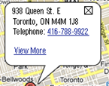

**View More Link** - will bring the user to the store’s information **.**

**浏览更多链接——用户能浏览商店信息。**

**Telephone Number Link** – Clicking this will open the device’s phone application and dial the store’s number.

电话号码链接——点此键，打开设备电话号码程序，并拨商店号码。

**Close Button** – Clicking the caption’s close button will close the caption. **(if no this button, when use click any place outside the pop window, it closed)**

**关闭按钮——点说明文字的关闭按钮，关闭说明文字。（如果没有此按钮，当用户点击弹出窗口外的任何地方，关闭说明文字）**

**List View** – Brings the user back to the results in list view (Page 1.2).

**列表浏览**——用户返回列表格式显示的结果（1.2页面）。

**Page 4.1 Local Coupon (List) 4.1页面 当地优惠劵（列表）**

**(need design) （需设计）**

**Interactive Elements 互动组件**

View: when user click the item, the detail page will be showed

浏览：用户点此项，显示详细页面

**Page 4.1 Local Coupon (Detail) 4.1页面 当地优惠券（详细）**

**(need design) （需设计）**

**Interactive Elements 互动组件**

forward, backward (icon): when user click, will loop display coupon's detail forward or backward

前翻，后翻（图标）：用户点击时，循环显示前翻或后翻优惠券详情

back: return to list page

返回：回到列表页面

**Page 5.1 Local Flyer 5.1页面 当地传单**

**(need design) （需设计）**

**Interactive Elements 互动组件**

View: when user click the item, the detail page will be showed, default use the first page of flyer

浏览：用户点此项，显示详情页面，默认使用传单首页

**Page 5.2 Local Flyer (detail Page) 5.2 当地传单（详情页面）**

**(need design) （需设计）**

**Interactive Elements 互动组件**

forward, backward (icon): when user click, will loop display flyer's pagel forward or backward

前翻，后翻（图标）：用户点击，循环显示前翻或后翻传单页面

back: return to list page

返回：回到列表页面

quick page: when user select a page, directly display that page

快速页面：用户选择某页面，直接显示该页面

**Page 6.1 Direction**

**Page 6.1 定向**

When directions button clicked, popup a window to show 3 options

**点击定向按钮，弹出窗口显示3个选项**

**Interactive Elements 互动组件**

Use current location/Postal or address 用户当前位置/邮编或地址

* Use current location, try to get current GPS location, if available, goto direction page/function (Google/Bing, etc)
* 使用用户当前位置，获取当前GPS位置，如果可用，到定位页面/功能(Google/Bing等)
* Postal or address, if user use address/postal to search store, the input textbox will be filled by previous input. When user click Go/Submit, like find store, first call Google/Bing webservice to resolve the address to lat/lon, and then call native/external function/app to show user the direction page.
* 邮编或地址，用户使用邮编/地址搜索商店，输入文本框将填充前一页的输入。当用户点击Go/Submit，像查找商店，首先调用Google/Bing webservice解析邮编或地址，再调用本地或外部功能或程序显示定位页面。

follow example use Google

下面是使用Google的例子

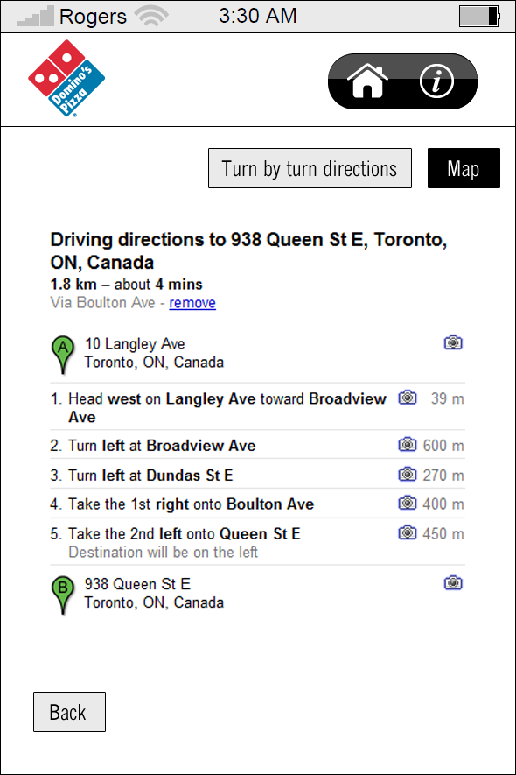

**Interactive Elements 互动组件**

**Turn by Turn Directions Button** – this will initially be in the “down” position. Allows the user to toggle between “turn by turn” directions, and directions shown on a map.

**Turn by Turn 定位按钮——这最初在“down”的位置。用户可以在“Turn by Turn”定位和地图上显示的定位之间切换。**

**Map Button** - Allows the user to see the directions visually. The directions will be shown on a map, and the directions will be denoted by a highlighted path.

**地图按钮**——用户形象直观的看到定位。定位显示在地图上，并以高亮的路径指出来。

**1.1.3**

